Hands-On Lab
Lab Manual
Creating Rich 2D and 3D Content with Windows Presentation Foundation

Please do not remove this manual from the lab

Information in this document is subject to change without notice. The example companies, organizations, products, people, and events depicted herein are fictitious. No association with any real company, organization, product, person or event is intended or should be inferred. Complying with all applicable copyright laws is the responsibility of the user. Without limiting the rights under copyright, no part of this document may be reproduced, stored in or introduced into a retrieval system, or transmitted in any form or by any means (electronic, mechanical, photocopying, recording, or otherwise), or for any purpose, without the express written permission of Microsoft Corporation.

Microsoft may have patents, patent applications, trademarked, copyrights, or other intellectual property rights covering subject matter in this document. Except as expressly provided in any written license agreement from Microsoft, the furnishing of this document does not give you any license to these patents, trademarks, copyrights, or other intellectual property.

© 2005 Microsoft Corporation. All rights reserved.

Microsoft, MS-DOS, MS, Windows, Windows NT, MSDN, Active Directory, BizTalk, SQL Server, SharePoint, Outlook, PowerPoint, FrontPage, Visual Basic, Visual C++, Visual J++, Visual InterDev, Visual SourceSafe, Visual C#, Visual J#, and Visual Studio are either registered trademarks or trademarks of Microsoft Corporation in the U.S.A. and/or other countries.

Other product and company names herein may be the trademarks of their respective owners.

Contents

Lab 1: Rich Content in WPF 3
Lab Objective 3
Exercise 1 – Create Static 2-D Content 3
Task 1 – Create a Circle 3
Task 2 – Create a More Complex Shape Using a Path 3
Exercise 2 – Add Animations and Media 3
Task 1 – Add Animations 3
Task 2 – Add Video 3
Exercise 3 – Create 3-D Content 3
Task 1 – Create a 3D Scene 3
Task 2 – Create a Cube 3
Task 3 – Map Other Content to the Surface of Your Cube 3
Task 4 – Map Your Animated 2-D Content onto the Cube 3
Lab Summary 3

Lab 1: Rich Content in WPF

Lab Objective
Estimated time to complete this lab: 60 minutes
The objective of this lab is to demonstrate the integration of the Windows Presentation Foundation’s rendering system as well as to show the power of XAML. You will create 2-D content, animate it, add video, and finally map it onto a rotating 3-D surface – and you will do all of this without writing a single line of C++, C#, or Visual Basic.

- Create static 2-D content
- Add animations and media
- Add 3-D
Note: Code snapshots representing the start-point for each task in the lab are available beneath the C:\Labs\DEV009 Creating Rich 2D and 3D Content in WPF\Source folder. These may be useful if you want to begin the lab somewhere in the middle, or if your project gets into an unrecoverable state.
The Microsoft Windows Software Development Kit (SDK) has been installed on this computer, and is available by clicking the “Microsoft Windows SDK” shortcut in the Start menu. Users are encouraged to keep the SDK open during their lab experience in order to develop a deeper knowledge of relevant concepts and find answers to common questions. Application Programming Interface (API) reference documentation is also available within the SDK.

Exercise 1 – Create Static 2-D Content
In this exercise, you will create a drawing of two circles and some text. You'll learn how to outline and fill Shape objects with solid colors, gradients, and visual objects. You’ll also learn how to use text as a background.
Your first task is to create a circle. To draw a circle, you create an Ellipse object and set its Width and Height properties so that they are equal to each other. In this example, you'll create an Ellipse that is 300 device-independent pixels (each device independent pixel, or DIP, is equal to 1/96th of an inch) wide by 300 device-independent pixels tall. You'll paint its outline (Stroke) and interior (Fill) with a brush.

Task 1 – Create a Circle
- Launch Visual Studio: from the Start menu, select All Programs > Microsoft Visual Studio 2005 > Microsoft Visual Studio 2005.
- From the main menu, select File > Open > Project/Solution.
- Navigate to C:\Labs\DEV009 Creating Rich 2D and 3D Content in WPF\Source \Ex1\Task1\. In this lab, each task has its own Visual Studio Project and folder.
- Open RichContent.sln.
- View the Window1.xaml file. Notice that this file is composed of a <Window> tag and its closing </Window> tag, as well as <Canvas> and </Canvas> tags inside of the Window. In this lab, all content will be placed between the Window tags, where the Canvas is now. Compile and run the code by pressing CTRL + F5.
- Note that the Canvas is contained within the Window, but that the Canvas is empty:
<Window x:Class="RichContent.Window1"
xmlns="http://schemas.microsoft.com/winfx/2006/xaml/presentation"
xmlns:x="http://schemas.microsoft.com/winfx/2006/xaml"
Title="RichContent"
>

<Canvas>
</Canvas>
</Window>

- Create a circle. You do this by creating an Ellipse object and giving it equal Width and Height settings. To make the Ellipse visible, give it a Stroke setting and a StrokeThickness. Run the application. Ellipse is just one of the predefined 2D shapes that are available to you. Instead of Ellipse, you could just as easily use Line, Polygon, Polyline, Rectangle, or Path. You’ll learn more about the Path shape in the next task.

<Window x:Class="RichContent.Window1"
xmlns="http://schemas.microsoft.com/winfx/2006/xaml/presentation"
xmlns:x="http://schemas.microsoft.com/winfx/2006/xaml"
Title="RichContent"
>

<Canvas>
<Ellipse Width="300" Height="300" Stroke="Purple" StrokeThickness="20">
</Ellipse>
</Canvas>

</Window>

Figure 1: A circle with a purple outline
When you set the ellipse's Stroke property to "Purple", you used abbreviated syntax to paint the ellipse's stroke with a purple SolidColorBrush. Alternatively, you could have written the following:

<Ellipse Width="300" Height="300" StrokeThickness="20">
<Ellipse.Stroke>
<SolidColorBrush Color="Purple" />
</Ellipse.Stroke>
</Ellipse>

In WPF, a Brush describes how to paint an area of the screen. A SolidColorBrush, for instance, paints an area with a solid color. Other types of brushes include LinearGradientBrush, RadialGradientBrush, ImageBrush, DrawingBrush, and VisualBrush. You will use a LinearGradientBrush in the next step to paint the circle's interior.
- Use a LinearGradientBrush to paint the circle interior with a linear gradient that transitions from yellow to red. A LinearGradientBrush paints a gradient along a line. The line’s start point and end point are defined by the LinearGradientBrush’s StartPoint and EndPoint properties This is not to be confused with its color interpolation scheme, which is also linear—all gradient brushes interpolate colors linearly between their gradient stops.
A LinearGradientBrush’s StartPoint and EndPoint properties define its gradient axis, the line along which the gradient blends its colors. If you don’t specify a StartPoint or EndPoint, they default to (0,0) and (1,1), which creates a diagonal gradient that starts at the top left corner of the area being painted and extends to the bottom-right corner. Note that these coordinates are relative to the size of the output area.

You use GradientStop objects to describe the colors that make up the gradient. Each gradient stop describes a color and that color’s position along gradient axis. Make the first gradient stop yellow and set its Offset property to 0, which places the gradient stop at the gradient’s StartPoint, (0,0). Make the second gradient stop red and set its Offset property to 1, which places the gradient stop at the gradient’s EndPoint, (1,1). Between these two points the color is linearly interpolated. After changing these, run your application again.

<Ellipse Width="300" Height="300"
Stroke="Purple" StrokeThickness="20">

<Ellipse.Fill>
<LinearGradientBrush>
<GradientStop Offset="0" Color="Yellow" />
<GradientStop Offset="1" Color="Red" />
</LinearGradientBrush>
</Ellipse.Fill>

</Ellipse>

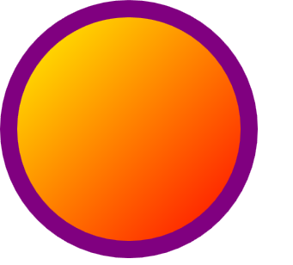
Figure 2: The circle from the previous step, now with a gradient fill
Because you did not specify a StartPoint or EndPoint, the LinearGradientBrush creates a diagonal gradient. Feel free to change the LinearGradientBrush’s StartPoint and EndPoint properties, as well as the Offset and Color values of the GradientStop objects. You may also add additional gradient stops.

- Give your circle a dashed outline by setting its StrokeDashArray property to “0.5 2”.
<Ellipse Width="300" Height="300"
Stroke="Purple" StrokeThickness="20"
StrokeDashArray="0.5,2">

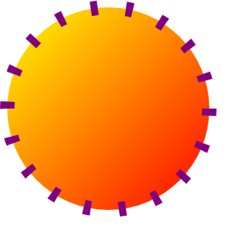
Figure 3: The circle, after giving it a dashed outline

Each value of the StrokeDashArray setting specifies the length of a dash or gap, relative to the shape's StrokeThickness. With the previous code (StrokeDashArray=“0.5,2"), you created a pattern composed of a dash that's 50% as long as the StrokeThickness followed by a space that's twice as long as the StrokeThickness.

- Give the dashes rounded edges by setting the ellipse’s StrokeDashCap to Round.
<Ellipse Width="300" Height="300"
Stroke="Purple" StrokeThickness="20"
StrokeDashArray="0.5,2" StrokeDashCap="Round">

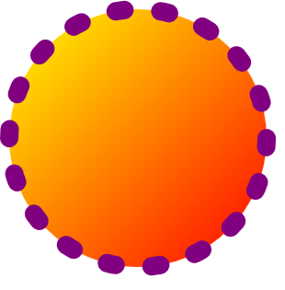
Figure 4: The circle, with rounded dashes
Other dash styles include Flat, Square, and Triangle.
- Replace the ellipse’s purple solid color stroke with a linear gradient that transitions from black to white. First, delete the Stroke property from within the Path tag. Then add the following XAML inside of your Ellipse tag.
<Window x:Class="RichContent.Window1"
xmlns="http://schemas.microsoft.com/winfx/2006/xaml/presentation"
xmlns:x="http://schemas.microsoft.com/winfx/2006/xaml"
Title="RichContent"
>

<Canvas>
<Ellipse Width="300" Height="300"
StrokeThickness="20"
StrokeDashArray="0.5,2" StrokeDashCap="Round">
<Ellipse.Fill>
<LinearGradientBrush>
<GradientStop Offset="0" Color="Yellow" />
<GradientStop Offset="1" Color="Red" />
</LinearGradientBrush>
</Ellipse.Fill>

<Ellipse.Stroke>
<LinearGradientBrush>
<GradientStop Offset="0" Color="Black" />
<GradientStop Offset="1" Color="White" />
</LinearGradientBrush>
</Ellipse.Stroke>

</Ellipse>
</Canvas >

</Window>

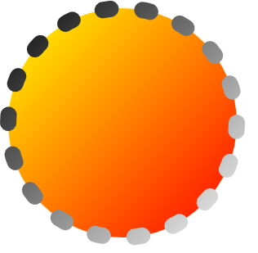
Figure 5: The circle, with a gradient outline

Task 2 – Create a More Complex Shape Using a Path
The Path class represents a more generalized shape than the predefined shape objects (Line, Rectangle, Ellipse, Polyline, Polygon). It enables you to create complex figures, such as curves, arcs, and combined shapes. In this task, you’ll create a path that’s equivalent to the circle you created in the previous task. You’ll then use the circle as part of a more complex shape.
- Replace the Ellipse that you created in the previous task with a Path. Give the Path the same Stroke and Fill settings that you gave the ellipse. Set its Width and Height properties to 800. Describe the path's contents (the shape to draw) using its Data property. The Data property accepts a Geometry. A Geometry is an abstract description of screen area, and depends on other objects to display it. To create a circle, you can use an EllipseGeometry, a predefined geometry similar to the predefined Ellipse shape you used earlier.

<Window x:Class="RichContent.Window1"
xmlns="http://schemas.microsoft.com/winfx/2006/xaml/presentation"
xmlns:x="http://schemas.microsoft.com/winfx/2006/xaml"
Title="RichContent"
>

<Canvas>

<Path Width="800" Height="800"
StrokeThickness="20" StrokeDashArray="0.5,2"
StrokeDashCap="Round" >

<Path.Data>
<EllipseGeometry RadiusX="150" RadiusY="150" Center = "200,200" />
</Path.Data>

<Path.Fill>
<LinearGradientBrush>
<GradientStop Offset="0" Color="Yellow" />
<GradientStop Offset="1" Color="Red" />
</LinearGradientBrush>
</Path.Fill>

<Path.Stroke>
<LinearGradientBrush>
<GradientStop Offset="0" Color="Black" />
<GradientStop Offset="1" Color="White" />
</LinearGradientBrush>
</Path.Stroke>
</Path>

</Canvas>

</Window>

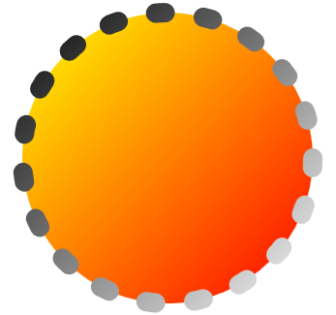
Figure 6: A circle created using a Path
You've just created a Path that's equivalent to the Ellipse you created in the first task. Now let's take advantage of the path's capabilities and make the shape more complex by using a CombinedGeometry to create a composite shape.

The CombinedGeometry class creates a single geometry using two input geometries and a combine mode. You can control how the CombinedGeometry combines its geometries by setting its GeometryCombineMode property to Union, Intersect, Exclude, or XOR. A CombinedGeometry is itself a Geometry, and may therefore be used to set a Path element’s Data property.

- Create a CombinedGeometry that combines two EllipseGeometry objects using the Union combine mode.
<Window x:Class="RichContent.Window1"
xmlns="http://schemas.microsoft.com/winfx/2006/xaml/presentation"
xmlns:x="http://schemas.microsoft.com/winfx/2006/xaml"
Title="RichContent"
>

<Canvas>

<Path Width="800" Height="800"
StrokeThickness="20" StrokeDashArray="0.5,2"
StrokeDashCap="Round" >

<Path.Data>
<CombinedGeometry GeometryCombineMode="Union">
<CombinedGeometry.Geometry1>
<EllipseGeometry Center="200,200" RadiusX="150" RadiusY="150" />
</CombinedGeometry.Geometry1>
<CombinedGeometry.Geometry2>
<EllipseGeometry Center="400,200" RadiusX="150" RadiusY="150" />
</CombinedGeometry.Geometry2>
</CombinedGeometry>
</Path.Data>

<Path.Fill>
<LinearGradientBrush>
<GradientStop Offset="0" Color="Yellow" />
<GradientStop Offset="1" Color="Red" />
</LinearGradientBrush>
</Path.Fill>

<Path.Stroke>
<LinearGradientBrush>
<GradientStop Offset="0" Color="Black" />
<GradientStop Offset="1" Color="White" />
</LinearGradientBrush>
</Path.Stroke>
</Path>

</Canvas>

</Window>

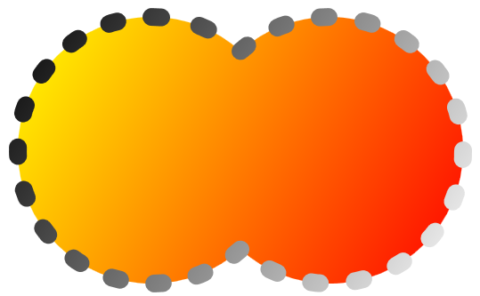
Figure 7: A combined geometry
So far, you've used a SolidColorBrush to paint an area with a solid color and a LinearGradientBrush to paint an area with a linear gradient. Now you'll use a VisualBrush to paint an area with a Visual. There are many types of Visual objects: controls, panels, and shapes are all types of visual objects. The number and variety of visual objects makes VisualBrush one of the most powerful and versatile Windows Presentation Foundation classes.

In the next step, you'll use a VisualBrush to paint the interior of your Path with some text.

- Create a VisualBrush and use it to paint the path's interior. To describe a VisualBrush’s contents, you set its Visual property, so named because it accepts input of type Visual. Set this Visual property with a TextBlock. Give the TextBlock a linear gradient background that transitions from yellow to red, just as before. Change the TextBlock's text or the colors of the gradient if you like.

<Path.Fill>

<VisualBrush>
<VisualBrush.Visual>
<TextBlock Text="Hello World" FontWeight="Bold" Padding="10">
<TextBlock.Background>
<LinearGradientBrush>
<GradientStop Offset="0" Color="Yellow" />
<GradientStop Offset="1" Color="Red" />
</LinearGradientBrush>
</TextBlock.Background>
</TextBlock>
</VisualBrush.Visual>
</VisualBrush>

</Path.Fill>


Figure 8: The path with a VisualBrush fill
VisualBrush has even more capabilities that aren’t shown here. For example, by setting its Viewport to "0,0,0.1,0.1" and setting its TileMode to Tile, you can create a pattern from the text it contains.

Exercise 1 Final Code

<Window x:Class="RichContent.Window1"
xmlns="http://schemas.microsoft.com/winfx/2006/xaml/presentation"
xmlns:x="http://schemas.microsoft.com/winfx/2006/xaml"
Title="RichContent"
>

<Canvas>

<Path Width="800" Height="800"
StrokeThickness="20" StrokeDashArray="0.5,2"
StrokeDashCap="Round" >

<Path.Data>
<CombinedGeometry GeometryCombineMode="Union">
<CombinedGeometry.Geometry1>
<EllipseGeometry Center="200,200" RadiusX="150" RadiusY="150" />
</CombinedGeometry.Geometry1>
<CombinedGeometry.Geometry2>
<EllipseGeometry Center="400,200" RadiusX="150" RadiusY="150" />
</CombinedGeometry.Geometry2>
</CombinedGeometry>
</Path.Data>

<Path.Fill>

<VisualBrush>
<VisualBrush.Visual>
<TextBlock Text="Hello World" FontWeight="Bold" Padding="10">
<TextBlock.Background>
<LinearGradientBrush>
<GradientStop Offset="0" Color="Yellow" />
<GradientStop Offset="1" Color="Red" />
</LinearGradientBrush>
</TextBlock.Background>
</TextBlock>
</VisualBrush.Visual>
</VisualBrush>

</Path.Fill>

<Path.Stroke>
<LinearGradientBrush>
<GradientStop Offset="0" Color="Black" />
<GradientStop Offset="1" Color="White" />
</LinearGradientBrush>
</Path.Stroke>
</Path>

</Canvas>

</Window>

Exercise 2 – Add Animations and Media
Now you can make your creation come alive by adding animation and media.
Windows Presentation Foundation provides an integrated animation system. To animate an object, you apply animations to its properties. There are different animation types for different property types: there’s a ColorAnimation for properties that take a Color value, a DoubleAnimation for properties that take a double value, a PointAnimation for animating properties that take a Point value, and so on. To make an EllipseGeometry move around the screen, you’d apply a PointAnimation to its Center property. To animate the width of a Rectangle, you’d apply a DoubleAnimation to its Width property.

Animations are contained within a Storyboard, an object that organizes and applies animations. To tell an animation which object to animate, you use the Storyboard.TargetName attached property. For an object to be animatable, you must give it a name. If the object is a framework element, you assign it a name by setting its Name property. If the object is not a framework element, you assign it a name using the x:Name markup extension. To tell an animation which property it should animate, you use the Storyboard.TargetProperty attached property.

Animations are triggered by events. To set your animation to play when a specific event occurs, you use an EventTrigger object. You control which event triggers an EventTrigger by setting its RoutedEvent property. When an EventTrigger is triggered, it performs any actions that you’ve associated with it. To start an animation, you use a BeginStoryboard action.

Task 1 – Add Animations
- Make the dash pattern you created in the previous example spin around the path. You do this by animating the path’s StrokeDashOffset property. Because the StrokeDashOffset property takes a double, you’ll use a DoubleAnimation. To make the DoubleAnimation animate from the property’s current value (in this example 0, because it wasn’t set) to 20, you set its To property to 20. Give it a Duration of 10 seconds, and make it repeat indefinitely. Make it start playing as soon as the path has been loaded. Remember to name the path so that it can be targeted by your animation.

<Window x:Class="RichContent.Window1"
xmlns="http://schemas.microsoft.com/winfx/2006/xaml/presentation"
xmlns:x="http://schemas.microsoft.com/winfx/2006/xaml"
Title="RichContent"
>

<Canvas>

<Path Name="MyPath" Width="800" Height="800"
StrokeThickness="20" StrokeDashArray="0.5,2"
StrokeDashCap="Round" >

<Path.Data>
<CombinedGeometry GeometryCombineMode="Union">
<CombinedGeometry.Geometry1>
<EllipseGeometry Center="200,200" RadiusX="150" RadiusY="150" />
</CombinedGeometry.Geometry1>
<CombinedGeometry.Geometry2>
<EllipseGeometry Center="400,200" RadiusX="150" RadiusY="150" />
</CombinedGeometry.Geometry2>
</CombinedGeometry>
</Path.Data>

<Path.Fill>
<VisualBrush>
<VisualBrush.Visual>
<TextBlock Text="Hello World" FontWeight="Bold" Padding="10">
<TextBlock.Background>
<LinearGradientBrush>
<GradientStop Offset="0" Color="Yellow" />
<GradientStop Offset="1" Color="Red" />
</LinearGradientBrush>
</TextBlock.Background>
</TextBlock>
</VisualBrush.Visual>
</VisualBrush>
</Path.Fill>

<Path.Stroke>
<LinearGradientBrush>
<GradientStop Offset="0" Color="Black" />
<GradientStop Offset="1" Color="White" />
</LinearGradientBrush>
</Path.Stroke>

<Path.Triggers>
<EventTrigger RoutedEvent="Path.Loaded">
<EventTrigger.Actions>
<BeginStoryboard>
<Storyboard>
<DoubleAnimation
Storyboard.TargetName="MyPath"
Storyboard.TargetProperty="StrokeDashOffset"
To="20" Duration="0:0:10"
RepeatBehavior="Forever" />
</Storyboard>
</BeginStoryboard>
</EventTrigger.Actions>
</EventTrigger>
</Path.Triggers>

</Path >

</Canvas >

</Window>

Notice how the system understands that the union of two geometries is a single geometry; the animated dashes flow seamlessly between the two. Try changing the speed of the animation by changing the Duration property of the DoubleAnimation.

- Next, to make the animated figure more eye-catching, make one of the EllipseGeometry objects fly around the screen. You do this by animating its Center property with a PointAnimation. Animate from (150,100) to (650,200) over three seconds, and make the animation repeat indefinitely. Assign the EllipseGeometry a name so that it can be targeted by the animation. Set the animation to start when the path is loaded.

<Path.Data>
<CombinedGeometry GeometryCombineMode="Union">
<CombinedGeometry.Geometry1>
<EllipseGeometry x:Name="MyEllipseGeometry"
Center="200,200" RadiusX="150" RadiusY="150" />
</CombinedGeometry.Geometry1>
<CombinedGeometry.Geometry2>
<EllipseGeometry Center="400,200" RadiusX="150" RadiusY="150" />
</CombinedGeometry.Geometry2>
</CombinedGeometry>
</Path.Data>

<Path.Triggers>
<EventTrigger RoutedEvent="Path.Loaded">
<EventTrigger.Actions>
<BeginStoryboard>
<Storyboard>
<DoubleAnimation
Storyboard.TargetName="MyPath"
Storyboard.TargetProperty="StrokeDashOffset"
To="20" Duration="0:0:10"
RepeatBehavior="Forever" />
</Storyboard>
</BeginStoryboard>

<BeginStoryboard>
<Storyboard>
<PointAnimation
Storyboard.TargetName="MyEllipseGeometry"
Storyboard.TargetProperty="Center"
From="150,100" To="650,200" Duration="0:0:3"
RepeatBehavior="Forever" AutoReverse="True"/>
</Storyboard>
</BeginStoryboard>

</EventTrigger.Actions>
</EventTrigger>
</Path.Triggers>

Figure 9: The animated path

Task 2 – Add Video
- In a previous step, you created a LinearGradientBrush and used it to paint the background of a TextBlock. Change your code so that the LinearGradientBrush paints the TextBlock’s Forground, instead of its Background.

<TextBlock Text="Hello World" FontWeight="Bold" Padding="10">

<TextBlock.Foreground>
<LinearGradientBrush>
<GradientStop Offset="0" Color="Yellow" />
<GradientStop Offset="1" Color="Red" />
</LinearGradientBrush>
</TextBlock.Foreground>

</TextBlock>

- Now, instead of using a gradient for the TextBlock’s background, use a video. This is done by creating a VisualBrush that contains a MediaElement, a type of element that can play video.
Set the MediaElement‘s Source property to the URI of the media file that you want to play. Double check that the MediaElement‘s Source property points to a video file that exists in that path or video will not play.

<TextBlock Text="Hello World" FontWeight="Bold" Padding="10">

<TextBlock.Foreground>
<LinearGradientBrush>
<GradientStop Offset="0" Color="Yellow" />
<GradientStop Offset="1" Color="Red" />
</LinearGradientBrush>
</TextBlock.Foreground>

<TextBlock.Background>
<VisualBrush>
<VisualBrush.Visual>
<MediaElement UnloadedBehavior="Play" Source="C:\Labs\DEV009 Creating Rich 2D and 3D Content in WPF\Source\apollo11_launchclip04.mpg" />
</VisualBrush.Visual>
</VisualBrush>
</TextBlock.Background>

</TextBlock>

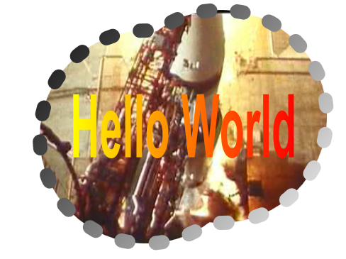

Exercise 2 Final Code
<Window x:Class="RichContent.Window1"
xmlns="http://schemas.microsoft.com/winfx/2006/xaml/presentation"
xmlns:x="http://schemas.microsoft.com/winfx/2006/xaml"
Title="RichContent"
>

<Canvas>

<Path Name="MyPath"
Width="800" Height="800"
StrokeThickness="20" StrokeDashArray="0.5,2"
StrokeDashCap="Round" >

<Path.Data>
<CombinedGeometry GeometryCombineMode="Union">
<CombinedGeometry.Geometry1>
<EllipseGeometry x:Name="MyEllipseGeometry"
Center="200,200" RadiusX="150" RadiusY="150" />
</CombinedGeometry.Geometry1>
<CombinedGeometry.Geometry2>
<EllipseGeometry Center="400,200" RadiusX="150" RadiusY="150" />
</CombinedGeometry.Geometry2>
</CombinedGeometry>

</Path.Data>

<Path.Fill>
<VisualBrush>
<VisualBrush.Visual>
<TextBlock Text="Hello World" FontWeight="Bold" Padding="10">
<TextBlock.Foreground>
<LinearGradientBrush>
<GradientStop Offset="0" Color="Yellow" />
<GradientStop Offset="1" Color="Red" />
</LinearGradientBrush>
</TextBlock.Foreground>
<TextBlock.Background>
<VisualBrush>
<VisualBrush.Visual>
<MediaElement UnloadedBehavior="Play" Source="C:\Labs\DEV009 Creating Rich 2D and 3D Content in WPF\Source \apollo11_launchclip04.mpg" />
</VisualBrush.Visual>
</VisualBrush>
</TextBlock.Background>
</TextBlock>
</VisualBrush.Visual>
</VisualBrush>
</Path.Fill>

<Path.Stroke>
<LinearGradientBrush>
<GradientStop Offset="0" Color="Black" />
<GradientStop Offset="1" Color="White" />
</LinearGradientBrush>
</Path.Stroke>

<Path.Triggers>
<EventTrigger RoutedEvent="Path.Loaded">
<EventTrigger.Actions>
<BeginStoryboard>
<Storyboard>
<DoubleAnimation To="20" Duration="0:0:10"
Storyboard.TargetName="MyPath"
Storyboard.TargetProperty="StrokeDashOffset"
RepeatBehavior="Forever" />
</Storyboard>
</BeginStoryboard>
<BeginStoryboard>
<Storyboard>
<PointAnimation From="150,100" To="650,200" Duration="0:0:3"
Storyboard.TargetName="MyEllipseGeometry"
Storyboard.TargetProperty="Center"
RepeatBehavior="Forever" AutoReverse="True"/>
</Storyboard>
</BeginStoryboard>
</EventTrigger.Actions>
</EventTrigger>
</Path.Triggers>
</Path>
</Canvas>

</Window>

Exercise 3 – Create 3-D Content
In this exercise, you create 3-D graphics by creating a 3-D scene and displaying it with a Viewport3D.
A Viewport3D is a 2-D FrameworkElement that contains a 3-D scene. A Viewport3D uses models, lights, and a camera to describe its 3-D scene, much like traditional 3-D APIs. Unlike traditional 3-D APIs, WPF 3-D is fully integrated into the platform. Not only can you place 3-D content in a 2-D scene, you can also place 2-D content in a 3-D scene (using a DrawingBrush or a VisualBrush).

Task 1 – Create a 3D Scene
- Clear the contents of Window1.xaml. Create a basic 3-D scene by copying the following code into Window1.xaml. This code describes a 3-D scene that contains one model (a double-sided plane), two lights, and a PerspectiveCamera. A camera defines the location of the eye point and it describes how the scene is translated into 2-D (the projection type). The camera you are using, a PerspectiveCamera, uses perspective projection. There is also an OrthographicCamera that uses orthographic projection and a MatrixCamera,which allows arbitrary ViewMatrix and ProjectionMatrix manipulation.

<Window
x:Class="RichContent.Window1"
xmlns="http://schemas.microsoft.com/winfx/2006/xaml/presentation"
xmlns:x="http://schemas.microsoft.com/winfx/2006/xaml"
Title="RichContent">
<Viewport3D>
<Viewport3D.Camera>
<PerspectiveCamera
FarPlaneDistance="20"
LookDirection="0,-0.65,-1"
UpDirection="0,1,0"
NearPlaneDistance="1"
Position="0,2,3" FieldOfView="40" />
</Viewport3D.Camera>
<ModelVisual3D>
<ModelVisual3D.Content>
<Model3DGroup>
<AmbientLight Color="White" />
<GeometryModel3D>
<GeometryModel3D.Geometry>
<MeshGeometry3D TriangleIndices="0,1,2 2,3,0 6,5,4 4,7,6" TextureCoordinates="1,1 1,0 0,0 0,1 0,1 0,0 1,0 1,1" Positions="-0.5,-0.5,0 -0.5,0.5,0 0.5,0.5,0 0.5,-0.5,0 -0.5,-0.5,0 -0.5,0.5,0 0.5,0.5,0 0.5,-0.5,0 " />
</GeometryModel3D.Geometry>
<GeometryModel3D.Material>
<DiffuseMaterial>
<DiffuseMaterial.Brush>
<VisualBrush>
<VisualBrush.Visual>
<TextBlock Text="Hello" />
</VisualBrush.Visual>
</VisualBrush>
</DiffuseMaterial.Brush>
</DiffuseMaterial>
</GeometryModel3D.Material>
</GeometryModel3D>
</Model3DGroup>
</ModelVisual3D.Content>
</ModelVisual3D>

</Viewport3D>
</Window>

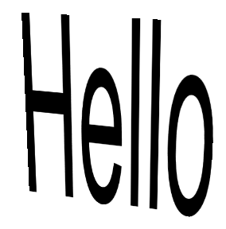
Figure 10: Text mapped onto a plane

- To rotate the Model3D on which the text is drawn, create a RotateTransform3D that uses a Rotation3D to describe a rotation along the Y axis. Use this transform to set the GeometryModel3D’s Transform property. Give the Rotation3D a name; you’ll animate it in the next step.
…
</GeometryModel3D.Geometry>

<GeometryModel3D.Transform>
<RotateTransform3D>
<RotateTransform3D.Rotation>
<AxisAngleRotation3D
x:Name="MyRotation3D" Angle="45" Axis="0 1 0"/>
</RotateTransform3D.Rotation>
</RotateTransform3D>
</GeometryModel3D.Transform>

<GeometryModel3D.Material>
…

Other types of 3D transforms include ScaleTransform3D and TranslateTransform3D.

- Make the plane spin by animating the Rotation3D you created in the previous step.

…
</Viewport3D.Models>

<Viewport3D.Triggers>
<EventTrigger RoutedEvent="Viewport3D.Loaded">
<EventTrigger.Actions>
<BeginStoryboard>
<Storyboard>
<DoubleAnimation From="0" To="360" Duration="0:0:3"
Storyboard.TargetName="MyRotation3D"
Storyboard.TargetProperty="Angle" RepeatBehavior="Forever" />
</Storyboard>
</BeginStoryboard>
</EventTrigger.Actions>
</EventTrigger>
</Viewport3D.Triggers>

</Viewport3D>

</Window>

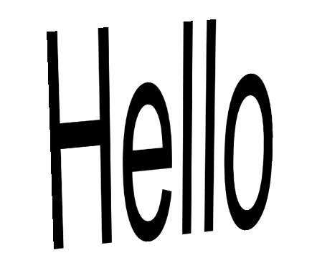
Figure 11: The animated plane

Task 2 – Create a Cube

- Substitute the following MeshGeometry3D, which defines a cube, for the MeshGeometry3D you created in the previous task.
<GeometryModel3D.Geometry>

<MeshGeometry3D
TriangleIndices="0,1,2 3,4,5 6,7,8 9,10,11 12,13,14 15,16,17 18,19,20 21,22,23 24,25,26 27,28,29 30,31,32 33,34,35 "
Normals="0,0,-1 0,0,-1 0,0,-1 0,0,-1 0,0,-1 0,0,-1 0,0,1 0,0,1 0,0,1 0,0,1 0,0,1 0,0,1 0,-1,0 0,-1,0 0,-1,0 0,-1,0 0,-1,0 0,-1,0 1,0,0 1,0,0 1,0,0 1,0,0 1,0,0 1,0,0 0,1,0 0,1,0 0,1,0 0,1,0 0,1,0 0,1,0 -1,0,0 -1,0,0 -1,0,0 -1,0,0 -1,0,0 -1,0,0 "
TextureCoordinates="1,1 1,0 0,0 0,0 0,1 1,1 0,1 1,1 1,0 1,0 0,0 0,1 0,1 1,1 1,0 1,0 0,0 0,1 1,1 1,0 0,0 0,0 0,1 1,1 1,0 0,0 0,1 0,1 1,1 1,0 0,0 0,1 1,1 1,1 1,0 0,0 "
Positions="-0.5,-0.5,-0.5 -0.5,0.5,-0.5 0.5,0.5,-0.5 0.5,0.5,-0.5 0.5,-0.5,-0.5 -0.5,-0.5,-0.5 -0.5,-0.5,0.5 0.5,-0.5,0.5 0.5,0.5,0.5 0.5,0.5,0.5 -0.5,0.5,0.5 -0.5,-0.5,0.5 -0.5,-0.5,-0.5 0.5,-0.5,-0.5 0.5,-0.5,0.5 0.5,-0.5,0.5 -0.5,-0.5,0.5 -0.5,-0.5,-0.5 0.5,-0.5,-0.5 0.5,0.5,-0.5 0.5,0.5,0.5 0.5,0.5,0.5 0.5,-0.5,0.5 0.5,-0.5,-0.5 0.5,0.5,-0.5 -0.5,0.5,-0.5 -0.5,0.5,0.5 -0.5,0.5,0.5 0.5,0.5,0.5 0.5,0.5,-0.5 -0.5,0.5,-0.5 -0.5,-0.5,-0.5 -0.5,-0.5,0.5 -0.5,-0.5,0.5 -0.5,0.5,0.5 -0.5,0.5,-0.5 "/>

</GeometryModel3D.Geometry>

Now you should have a rotating cube with text printed on it. Try changing the camera’s Position property setting.


Figure 12: Text mapped onto a cube

Task 3 – Map Other Content to the Surface of Your Cube
- Change the surface of the cube so that it displays a video. You do this by changing the VisualBrush’s content from a TextBlock…

<DiffuseMaterial>
<DiffuseMaterial.Brush>
<VisualBrush>
<VisualBrush.Visual>
<TextBlock Text="Hello" />
</VisualBrush.Visual>
</VisualBrush>
</DiffuseMaterial.Brush>
</DiffuseMaterial>

…to a MediaElement:

<DiffuseMaterial>
<DiffuseMaterial.Brush>
<VisualBrush>
<VisualBrush.Visual>
<MediaElement LoadedBehavior="Play" UnloadedBehavior="Close" Source = "C:\Labs\DEV009 Creating Rich 2D and 3D Content in WPF\Source\apollo11_launchclip04.mpg" />
</VisualBrush.Visual>
</VisualBrush>
</DiffuseMaterial.Brush>
</DiffuseMaterial>

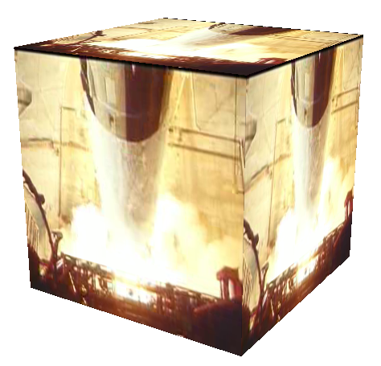
Note: Double check that the MediaElement‘s Source property points to a video file that exists in that path or video will not play.

- Now change the VisualBrush’s contents again, this time to an Ellipse.
<DiffuseMaterial>
<DiffuseMaterial.Brush>
<VisualBrush>
<VisualBrush.Visual>

<Ellipse Width="300" Height="300"
Stroke="Purple" StrokeThickness="20">
<Ellipse.Fill>
<LinearGradientBrush>
<GradientStop Offset="0" Color="Yellow" />
<GradientStop Offset="1" Color="Red" />
</LinearGradientBrush>
</Ellipse.Fill>
</Ellipse>

</VisualBrush.Visual>
</VisualBrush>
</DiffuseMaterial.Brush>
</DiffuseMaterial>
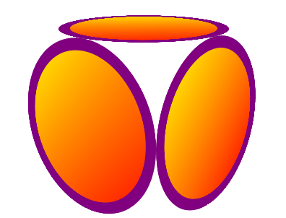

Task 4 – Map Your Animated 2-D Content onto the Cube

- Map the Path that you created in Exercise 2 onto the surface of the cube. To do this, delete the Ellipse from the previous task and replace it with your path from Exercise 2.

<GeometryModel3D.Material>
<DiffuseMaterial>
<DiffuseMaterial.Brush>
<VisualBrush>
<VisualBrush.Visual>

<Path Name="MyPath"
Width="800" Height="800"
StrokeThickness="20" StrokeDashArray="0.5,2"
StrokeDashCap="Round">

<Path.Data>
<CombinedGeometry GeometryCombineMode="Union">
<CombinedGeometry.Geometry1>
<EllipseGeometry x:Name="MyEllipseGeometry"
Center="200 200" RadiusX="150" RadiusY="150" />
</CombinedGeometry.Geometry1>
<CombinedGeometry.Geometry2>
<EllipseGeometry Center="400 200" RadiusX="150" RadiusY="150" />
</CombinedGeometry.Geometry2>
</CombinedGeometry>
</Path.Data>

<Path.Fill>
<VisualBrush>
<VisualBrush.Visual>
<TextBlock Text="Hello World" FontWeight="Bold" Padding="10">
<TextBlock.Foreground>
<LinearGradientBrush>
<GradientStop Offset="0" Color="Yellow" />
<GradientStop Offset="1" Color="Red" />
</LinearGradientBrush>
</TextBlock.Foreground>
<TextBlock.Background>
<VisualBrush>
<VisualBrush.Visual>
<MediaElement LoadedBehavior="Play" UnloadedBehavior="Close" Source="C:\Labs\DEV009 Creating Rich 2D and 3D Content in WPF\Source\apollo11_launchclip04.mpg"/>
</VisualBrush.Visual>
</VisualBrush>
</TextBlock.Background>
</TextBlock>
</VisualBrush.Visual>
</VisualBrush>
</Path.Fill>

<Path.Stroke>
<LinearGradientBrush>
<GradientStop Offset="0" Color="Black" />
<GradientStop Offset="1" Color="White" />
</LinearGradientBrush>
</Path.Stroke>

<Path.Triggers>
<EventTrigger RoutedEvent="Path.Loaded">
<EventTrigger.Actions>
<BeginStoryboard>
<Storyboard>
<DoubleAnimation To="20" Duration="0:0:10"
Storyboard.TargetName="MyPath"
Storyboard.TargetProperty="StrokeDashOffset"
RepeatBehavior="Forever" />
</Storyboard>
</BeginStoryboard>
<BeginStoryboard>
<Storyboard>
<PointAnimation From="150,100" To="650,200" Duration="0:0:3"
Storyboard.TargetName="MyEllipseGeometry"
Storyboard.TargetProperty="Center"
RepeatBehavior="Forever" AutoReverse="True"/>
</Storyboard>
</BeginStoryboard>
</EventTrigger.Actions>
</EventTrigger>
</Path.Triggers>
</Path>

</VisualBrush.Visual>
</VisualBrush>
</DiffuseMaterial.Brush>
</DiffuseMaterial>

</GeometryModel3D.Material>

</GeometryModel3D>

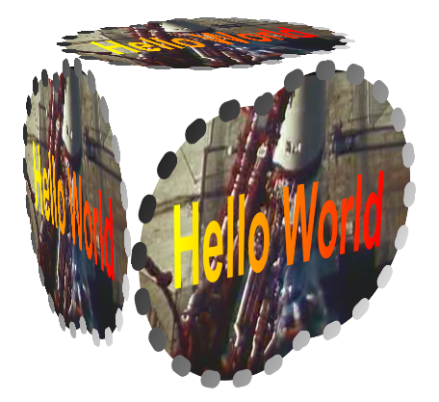
Figure 13: The path from Exercise 2, mapped onto the surface of a cube

- To get the animations working again, move the DashOffset animation and the EllipseGeometry animation from the path’s EventTrigger to the Viewport3D’s EventTrigger. Delete the path’s Path.Trigger tags and everything they contain.
<Viewport3D.Triggers>
<EventTrigger RoutedEvent="Viewport3D.Loaded">
<EventTrigger.Actions>
<BeginStoryboard>
<Storyboard>
<DoubleAnimation From="0" To="360" Duration="0:0:3"
Storyboard.TargetName="MyRotation3D"
Storyboard.TargetProperty="Angle" RepeatBehavior="Forever" />
</Storyboard>
</BeginStoryboard>

<BeginStoryboard>
<Storyboard>
<DoubleAnimation To="20" Duration="0:0:10"
Storyboard.TargetName="MyPath"
Storyboard.TargetProperty="StrokeDashOffset"
RepeatBehavior="Forever" />
</Storyboard>
</BeginStoryboard>
<BeginStoryboard>
<Storyboard>
<PointAnimation From="150,100" To="650,200" Duration="0:0:3"
Storyboard.TargetName="MyEllipseGeometry"
Storyboard.TargetProperty="Center"
RepeatBehavior="Forever" AutoReverse="True"/>
</Storyboard>
</BeginStoryboard>

</EventTrigger.Actions>
</EventTrigger>
</Viewport3D.Triggers>

Lab Summary
In this lab you performed the following exercises.
- Created a 2-D scene
- Animated that 2-D scene and added a playing video
- Mapped that entire scene onto the surface of an animated 3-D cube

It should be noted that since this entire lab was written in XAML, you can run through the whole thing in XAMLPad, a XAML editor and viewer which can give you “live updates” as you edit your xaml by reparsing it with each keystroke. This is great for experimenting with WPF.
You can launch XAMLPad by opening the Start menu, selecting All Programs, then selecting Microsoft Windows SDK, then Tools, and finally XAMLPad. Because XAMLPad automatically saves its state when it’s closed, you might find some XAML already present in XAMLPad’s text entry box. Delete whatever XAML you find.

